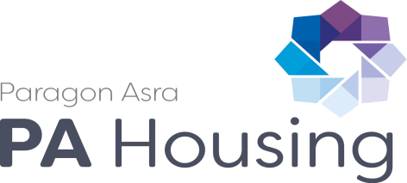
Please read this declaration carefully before you sign and date it.

Once you sign and date this form it becomes a legally binding document. Read the conditions of the declaration carefully before you sign. If there is any part of the declaration you do not understand, it is your responsibility to find someone to explain it to you.

- To the best of my knowledge and belief the information that has been provided on my application form is true, complete and correct.

- I understand that the information I have provided will be used to help determine my eligibility to housing.

- Where other people’s personal information is given on the form, I confirm that they have consented to its use

- I understand that any information given by me relating to this housing application, or given with my consent by others, will be placed on Paragon Asra’s housing register.

- I will immediately declare any changes in the information I have provided while I am waiting to be offered accommodation.

- I understand that failure to do so may be regarded as a criminal offence, possibly affecting my application and resulting in court action against me.

- I give permission for you to contact individuals or agencies in order to support my application for rehousing, also other individuals and agencies such as the health authority, social, education or housing services, the Probation Service, the police, courts, other local authority directorates, and Experian in order to process my application. (Please note any credit score obtained via Experian will not influence the outcome of your application but will be used in order to support and verify details you have declared on your application)

- I consent to the collection, verification and retention of my sensitive information in accordance with the Immigration Act 2014 and the Data Protection Act 1998

- I understand that if I give false or misleading information or I omit information for the purpose of obtaining housing, it may be regarded as a criminal offence and action could be taken against me, including court action and recovery

- I agree to information about me, my household and my tenancy being shared with the relevant Local Authority for the purpose of homeless prevention should this ever be required at any stage were I to go on to become a tenant of Paragon Asra Housing..

I confirm that I have read, understand and agree to the terms laid out in the declaration.
Applicant 1 you sign and date this form it becomes a legally binding document. Read the conditions
Print name: Signature: Date:

Applicant 2

Print name: Signature: Date:

